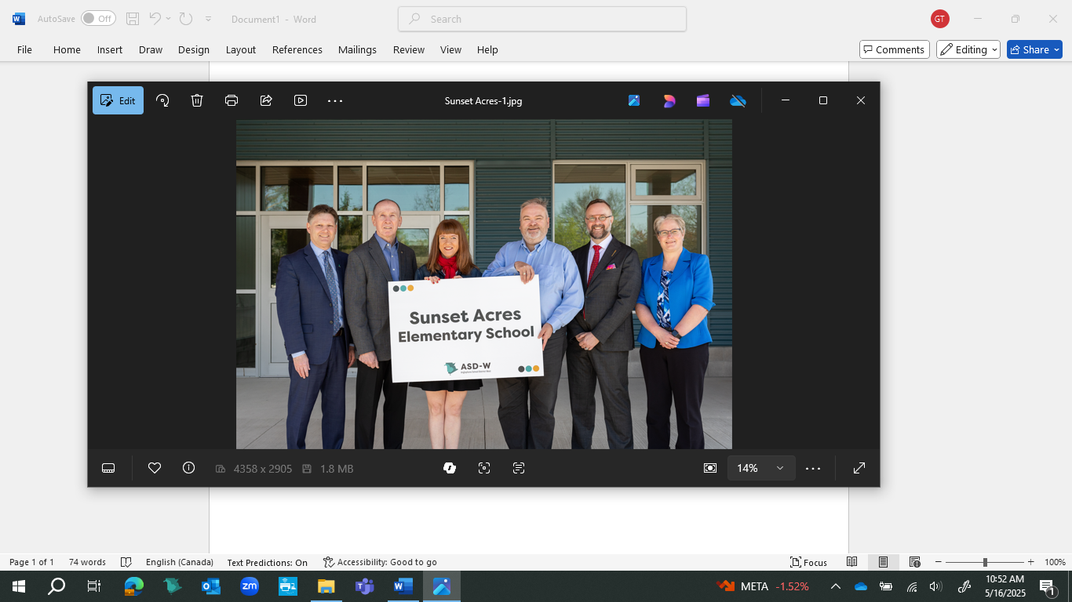

**Name chosen for new Fredericton school**

The new anglophone kindergarten-to-Grade 5 school opening in Fredericton’s Sunset Acres neighbourhood this September will be named Sunset Acres Elementary School. From left: David McTimoney, superintendent of Anglophone West School District; Thomas Geburt, chair of the district education council; Education and Early Childhood Development Minister Claire Johnson; Jason Burns, principal; Luke Randall, minister responsible for economic development and small business; and Darla Day, the district’s director of schools.