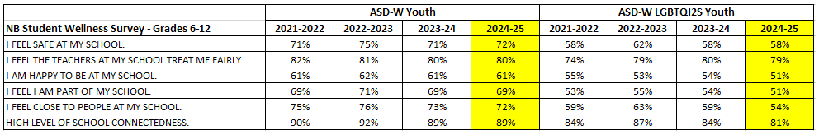
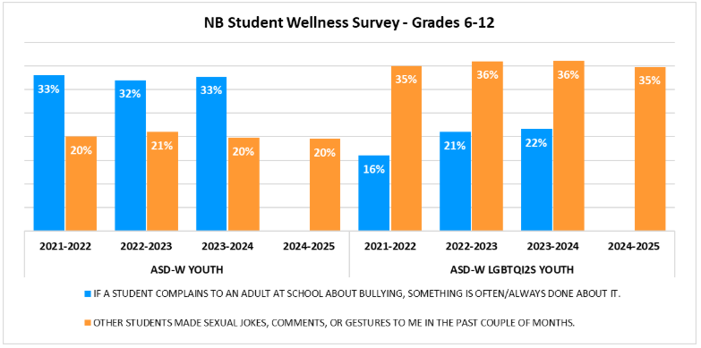
Please note that “Adults deal with bullying quickly whenever it happens” was not in the 2024-25 version of the survey. As such, there is no result for this question in the graph above.
